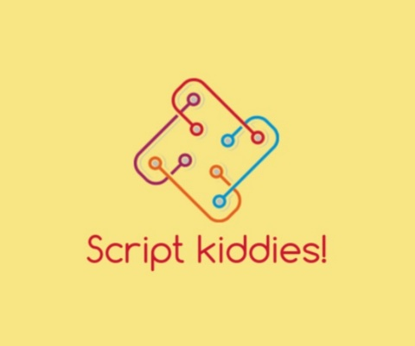



**Coding Challenge**

**2020**

Alexander Thompson

Elham Khorsandian

Elisabeth Zuyeva

Farhan Tariq

Madhukar Chinnappa

Prathees Kumaravel

Date: 21-23 October 2020

Contents

Abstract: 3

Project overview: 3

The Team: 3

Vision: 3

Values: 3

Guidelines: 3

Roles: 4

Our performance: 4

Steps: 4

Methodology: 4

Communication: 4

Technology & Tools: 4

Result: 5

Barriers and bottlenecks: 5

# Abstract:

The coding challenge program is designed by Deutsche Bank in collaboration with QA. In this three-day program, pre-defined tasks in the form of requirements were assigned to groups of five to six people to work on an Application improvement project, which was expected to be shown and reviewed in the form of a short presentation by the end of the challenge.

# Project overview:

In this Challenge, our team was tasked with working on the 'App Improvements' project for the bank's 'Investment Services App', which has been widely criticized recently. There were different issues from the bank´s stakeholders allocated to the group. Each issue was defined in the form of a requirement with a different degree of importance. The most important requirements of the project were briefly as following:

1. Displaying the successful connection to the database
2. Enabling the users to enter their Usernames and Passwords
3. Persistant streamed data.
4. Data normalization and no replicated data
5. Displaying the average buy and sell prices for each instrument during the period
6. Displaying the ending positions for each dealer
7. Displaying the realized profit/loss for each dealer
8. Displaying the effective profit/loss for each dealer

# The Team:

Vision:

We deliver what the customer needs tomorrow!

Values:

* Helpfulness
* Respect
* Commitment
* Agility
* Quality

Guidelines:

* We pay attention to the structure of our software code! (SOLID design principles instead of STUPID code)
* We work well as a team and give everyone an opportunity to contribute!
* We know the importance of testing and develop tests against which software is written!
* We document our work properly!

Roles:

We have structured our team in the following roles:

Product Owner: Elisabeth

Scrum master: Elham

Development team: Alexander, Farhan, Madhukar, Prathees

# Our performance:

## Steps:

In the first step of this project, we reviewed and prioritized tasks. As the next step, we divided the roles according to the abilities and interests of each member of the group. To speed up the tasks, the Development team was split into two sub-branches, Back-end and Front-end, which eventually merged after progressing and joint meetings.

## Methodology:

This project has been accomplished through an Agile manner. As one of the agile methodologies and to maintain the dynamism and increase the effectiveness of the project, we used the Scrum method. We have also used the Kanban board as a task management tool to receive an overview of the allocation of tasks and priorities.

In each 2 days of the project, we had a catch-up in the beginning of the day and a retrospective by the end of the day to discuss about our progress, sprints and to modify the Kanban board.

## Communication:

The main tool for the communication among team members during the project was Cisco WebEx. We have used GitHub to enable us a seamless collaboration without compromising the integrity of the project and as a tool of version control and also a Kanban board to review and track the tasks. WhatsApp and Google Docs were other means of communications and data exchange for the group.

## Technology & Tools:

All trainees were required to use LoD (Learn on Demand VMs) during the project. In addition, the following technologies and tools have been used by our team:

* Technology:
  + Python
  + ReactJS
  + SQL & MySQL
  + JSON
  + RESTful Services
  + Docker
* Tools:
* GitHub
* PyCharm
* MySQL Workbench
* Visual Studio Code
* MS Visio

# Result:

The result will be shown in our live demo.

Link to our GitHub Project: <https://github.com/Pikay93/CC_Team05>

# Barriers and bottlenecks:

During this project, our group faced some obstacles and barriers. The first problem was the time constraints considering the heavy workload to complete the project. In addition, one of the most important limitations was the impossibility of cooperation and collaboration in person due to the current situation in of Covid-19. In this situation, it was not possible to conduct this training in person, and all the interactions of our group were done virtually, which was more time consuming than face-to-face interactions. Another impediment was, that the team had to set up the environment on the LoD one more time on Wednesday. This affected the starting point of the team – we were able to start developing on Wednesday from 2 pm instead of 10 am. During the project time we also experienced some Git issues. Another barrier was our insufficient knowledge on ReactJS.